Task on Cloudfront and Route53
1. Configure VPC peering in cross regions.
Objective
Connect two VPCs located in different AWS Regions.
Prerequisites
Two VPCs in different regions
CIDR ranges must not overlap
Two EC2 instances (optional for testing)
Steps
- Create VPC-A (eu-stockholm)
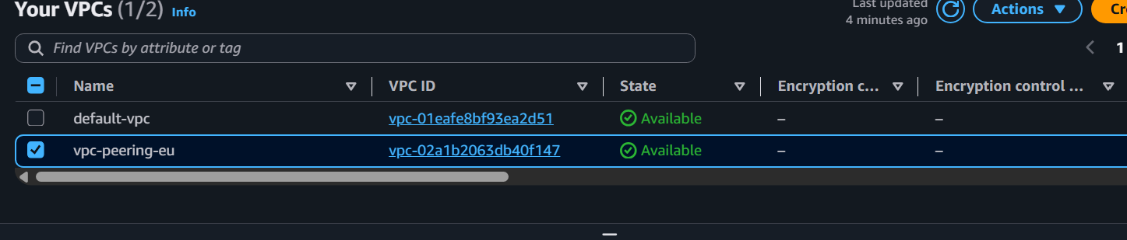
2. Create VPC-B (ap-mumbai).
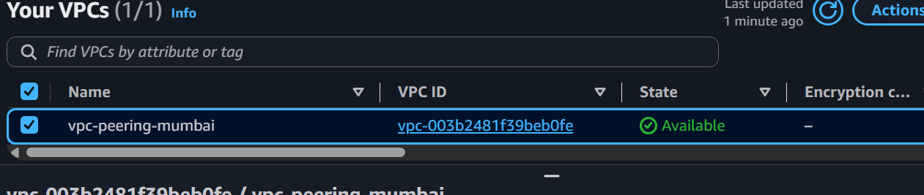
3. Create a VPC Peering Connection.
4. Select:
o Requester VPC → Region 1
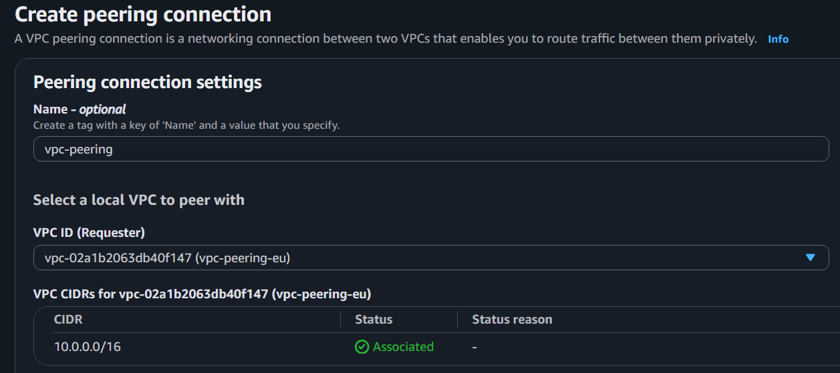
o Accepter VPC → Region 2
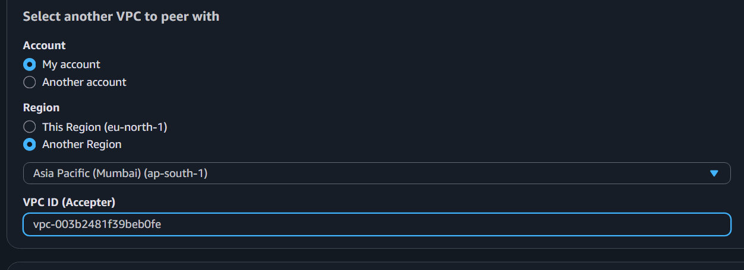
5. Accept the peering request from Region 2.
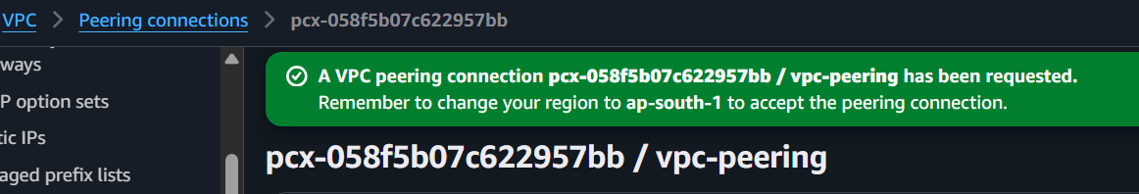
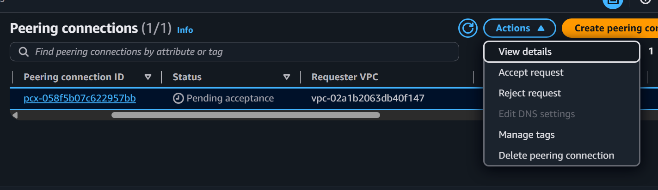
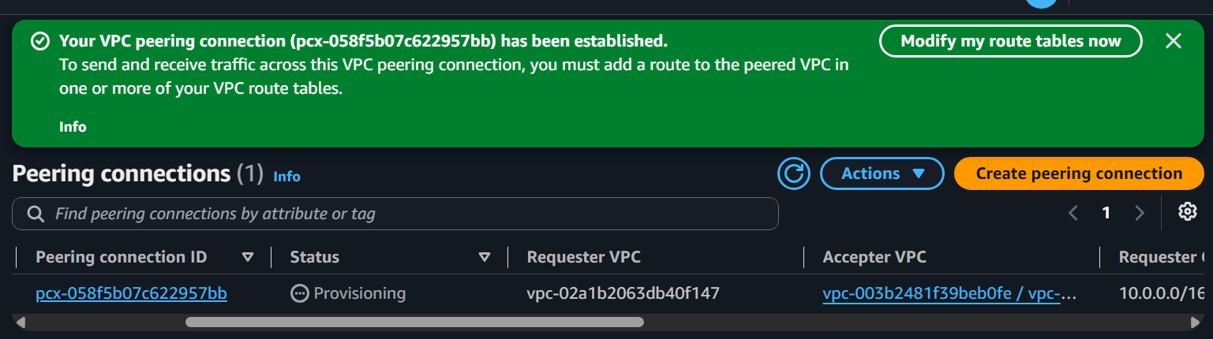
6. Update route tables in both VPCs.
2. Purchase one domain from GoDaddy.
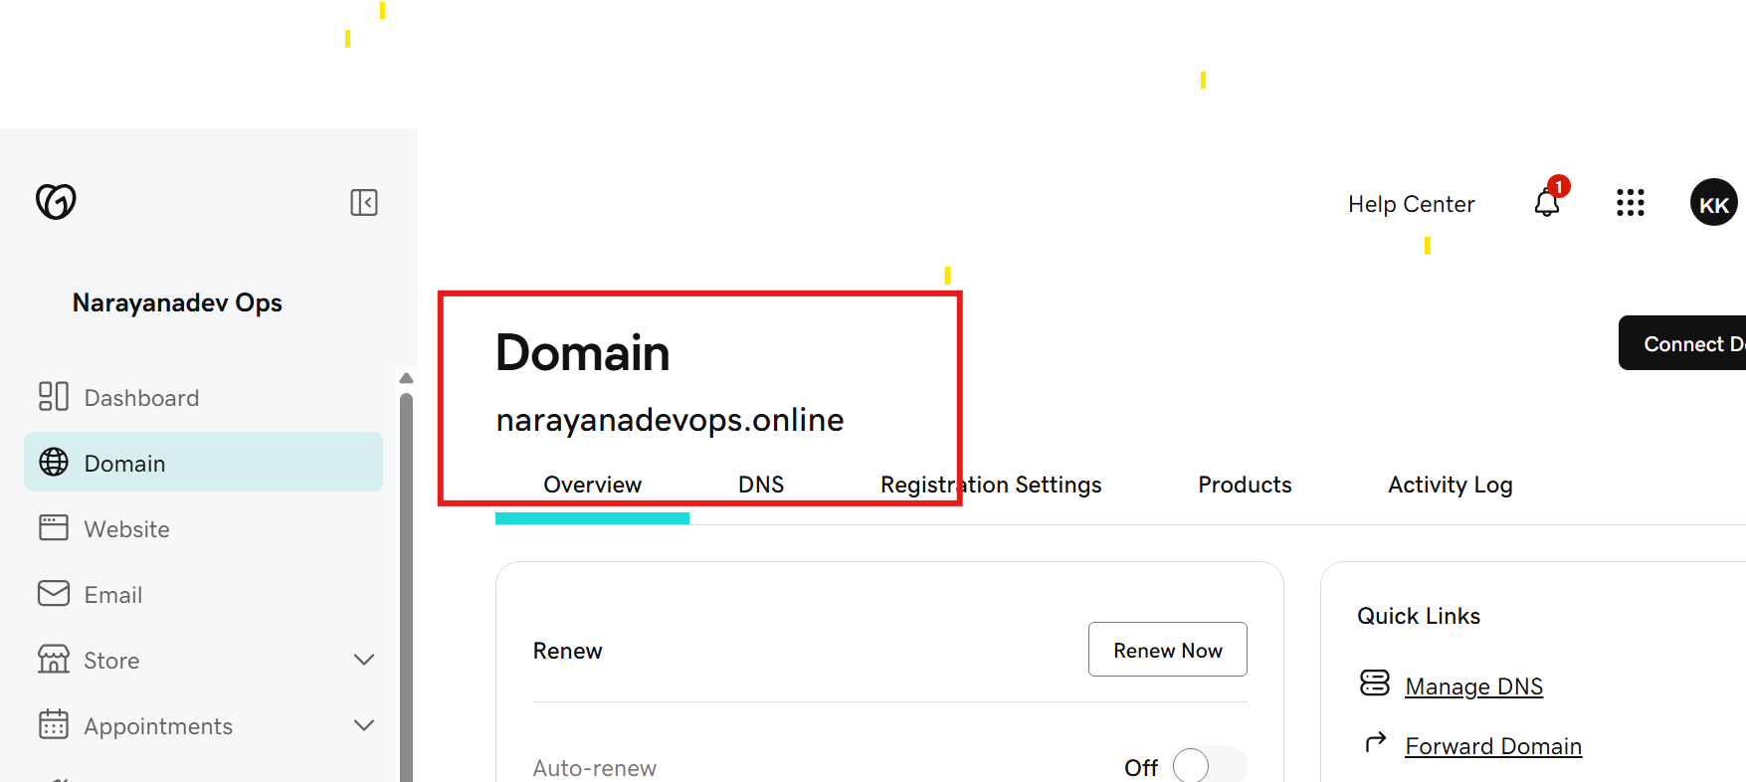
3. Deploy static website in S3.
Step 1: Create an S3 Bucket
AWS Console → S3 → Create bucket
Bucket name: narayanadevops.online
Region: Choose your preferred region.
Uncheck Block all public access.
Click Create bucket.
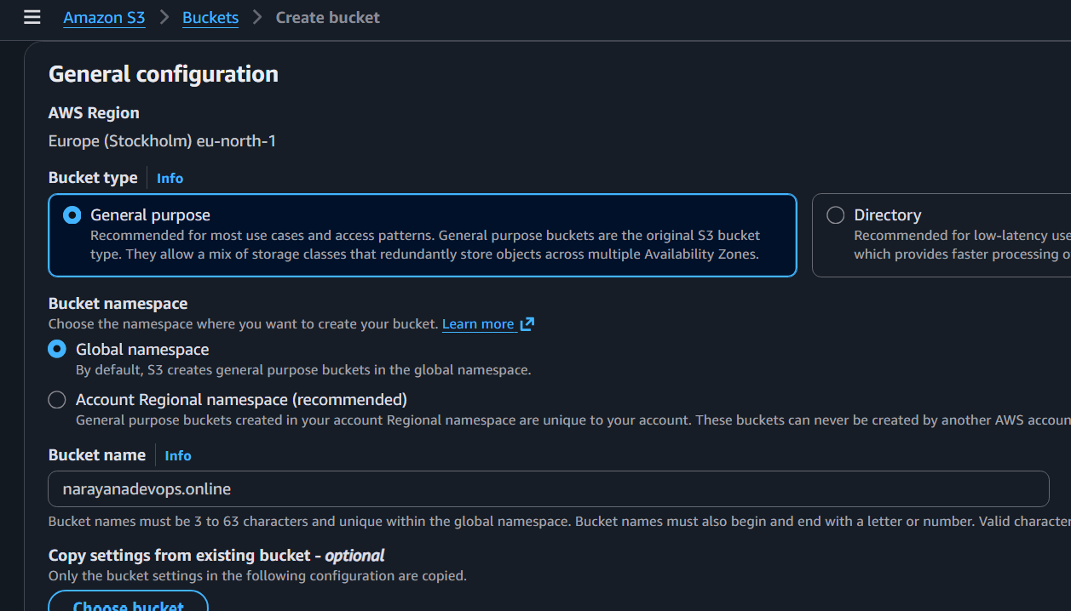
Step 2: Upload Website Files
Open the bucket.
Click Upload.
Upload:
1.index.html
2.error.html
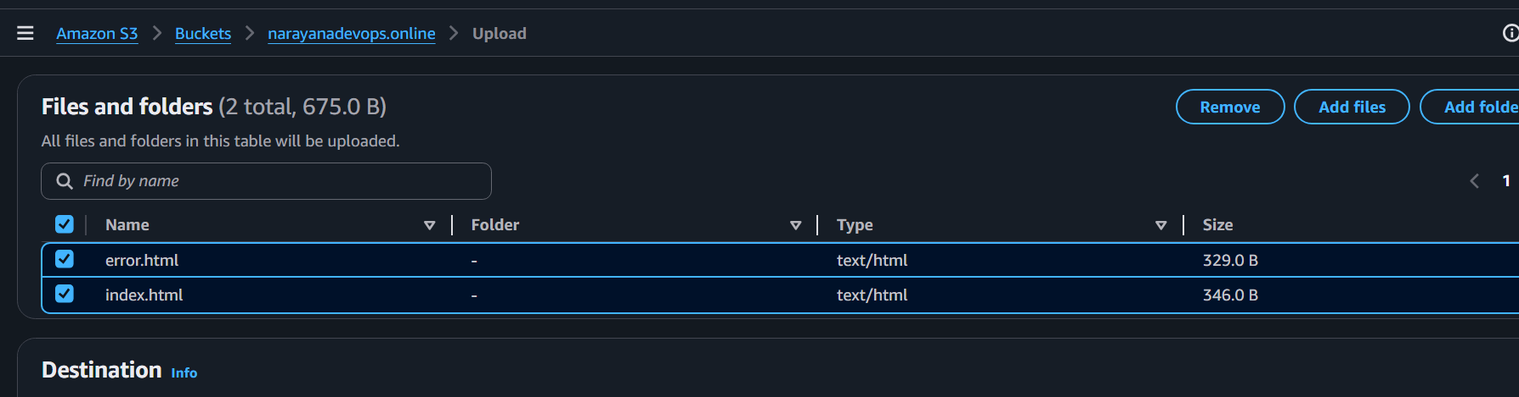
Step 3: Enable Static Website Hosting
Go to Properties.
Scroll to Static website hosting.
Click Edit.
Enable Static website hosting.
Hosting type: Host a static website.
Index document: index.html
Error document: error.html
Click Save changes.
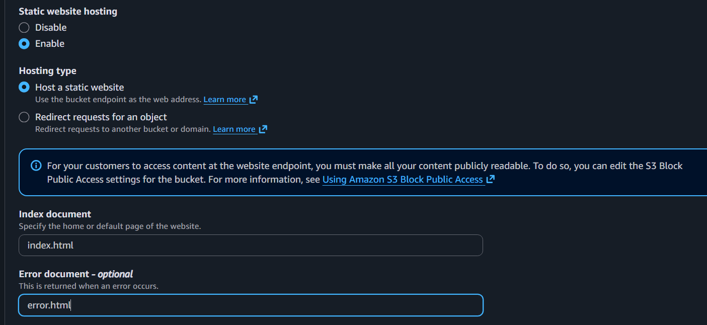
Step 4: Add Bucket Policy
Go to Permissions → Bucket Policy → Paste:
Click Save.
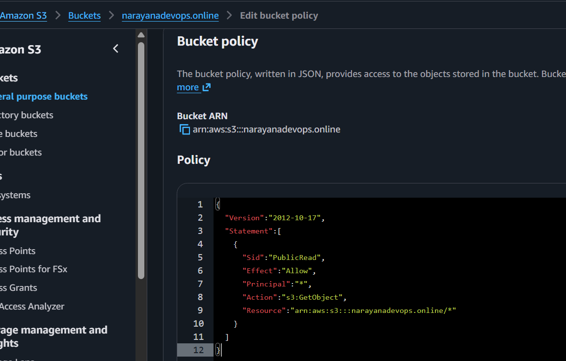
Step 5: Test the Website
Go to Properties.
Copy the Bucket Website Endpoint.
Open it in your browser.
Your website should load.
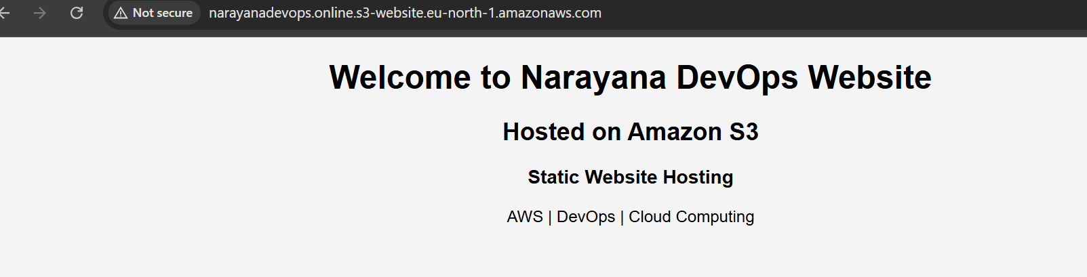
4. Create a CDN and attach one SSL certificate.
Outcome
A CloudFront distribution is created and secured with an SSL/TLS certificate, allowing
users to access the website over HTTPS.
Objective
To improve website performance using a CDN and secure traffic using HTTPS.
Prerequisites
AWS Account
Static website hosted in an S3 bucket (or another supported origin)
Domain name (optional but recommended)
Public hosted zone in Route 53 (if using a custom domain)
Step 1: Request an SSL Certificate
Important: CloudFront accepts ACM certificates only from the N. Virginia (us-east-1)
region.
1. Open AWS Certificate Manager (ACM).
2. Switch to N. Virginia (us-east-1), you should only use N.virginia region for certificate request if any other region it won’t allow
3. Click Request Certificate.
4. Select Request a public certificate.
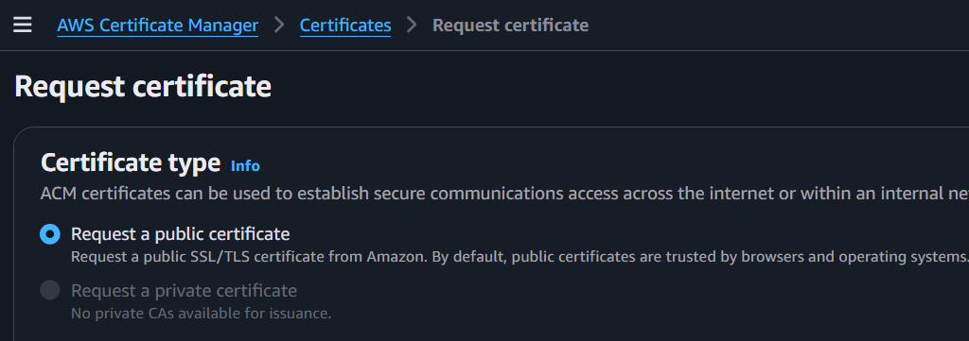
5. Enter your domain name:
6. Choose DNS Validation.
7. Click Request.
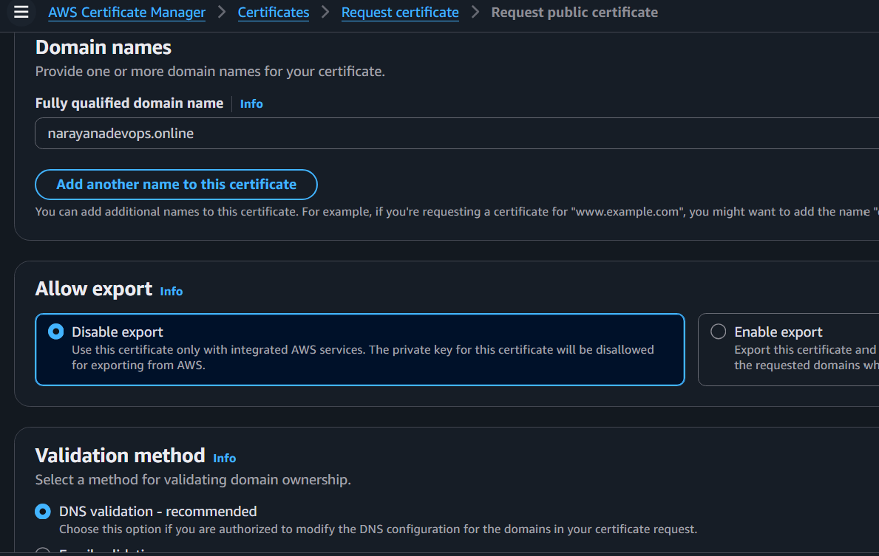
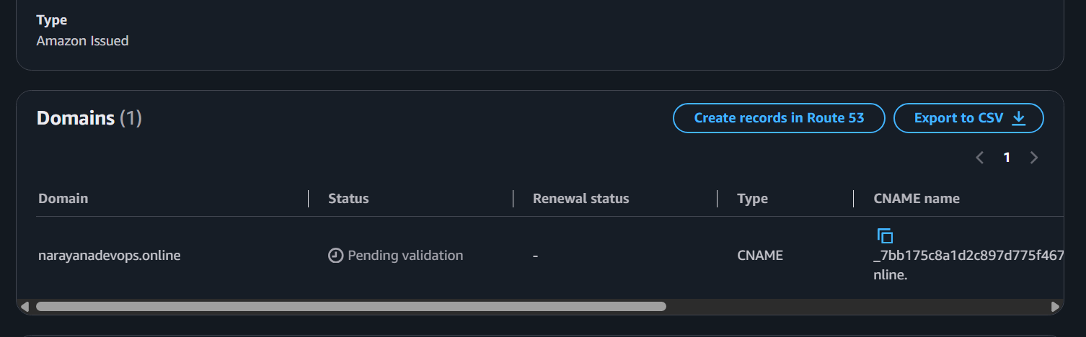
8. GoDaddy Add the provided CNAME record to your DNS (your domain provider).
Step 2: Add the Record in GoDaddy
1. Log in to GoDaddy.
2. Go to Domains.
3. Select satishdevops.online.
4. Click DNS or Manage DNS.
5. Click Add Record.
Domain Name: narayanadevops.online
Status: Pending validation
A CNAME Name
_7bb175c8a1d2c897d775f46755fcea5d.narayanadevops.online
A CNAME Value
_003f2d2c1cfa679ad226b55811b9dcfa.jkddzztszm.acm-validations.aws.
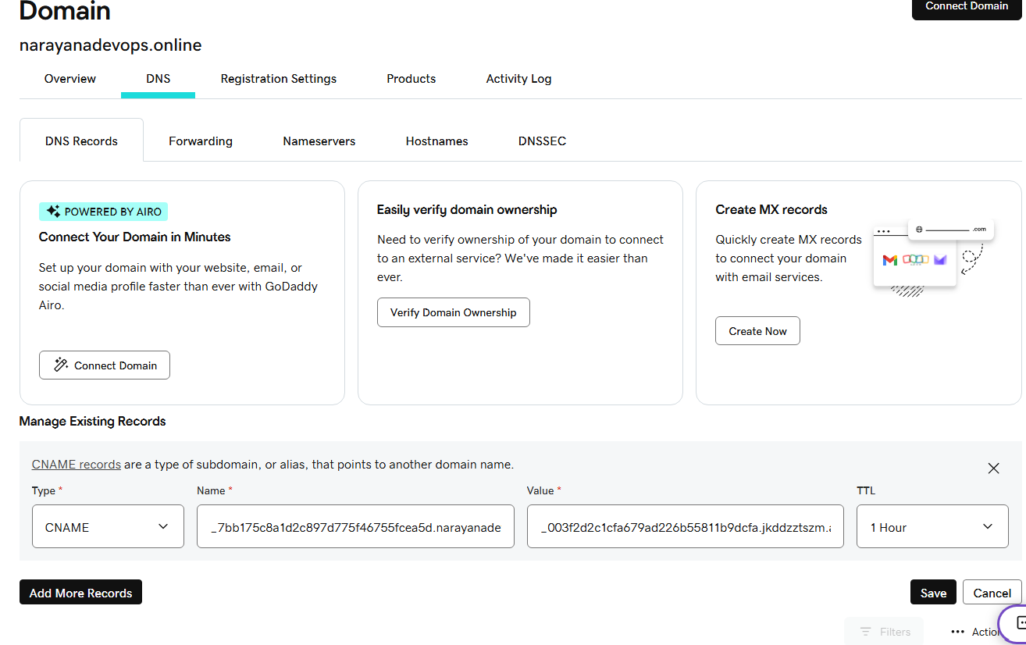

9. Wait until the certificate status changes to Issued. 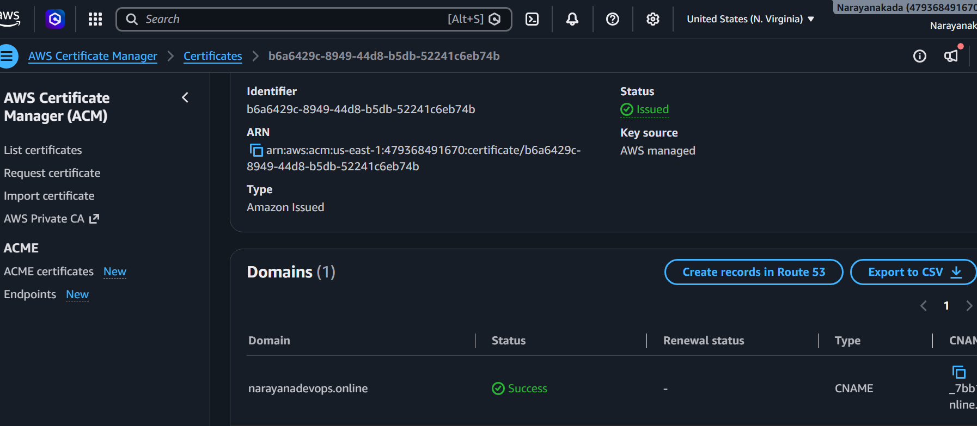
Step 2: Create a CloudFront Distribution
1. Open CloudFront.
2. Click Create Distribution.
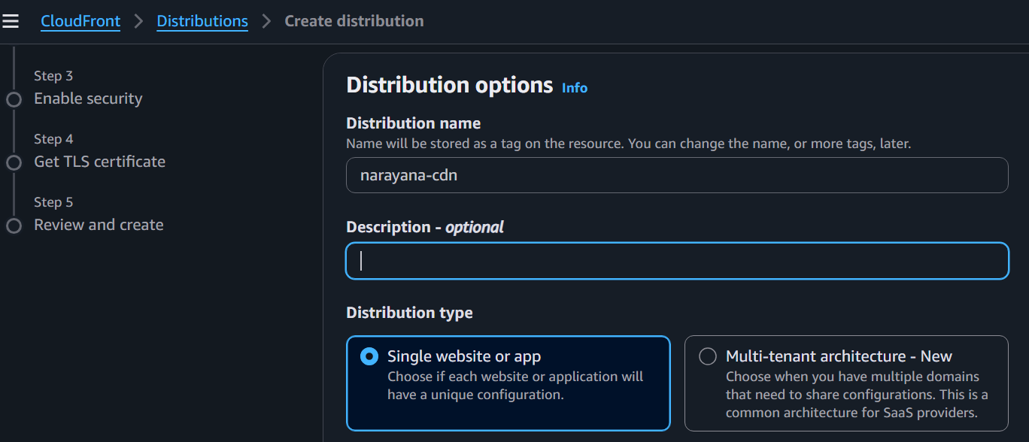
3. Under Origin, select your S3 bucket (or other origin).
For a static website hosted in S3, configure the Origin section like this.
1. Origin type
Select:
✅ Amazon S3
2. S3 origin
Click Browse S3.
Select your bucket: narayanadevops.online
3. Origin path
Leave it blank.
4. Origin settings
Select:
✅ Use recommended origin settings
5. Cache settings
Select:
✅ Use recommended cache settings tailored to serving S3 content
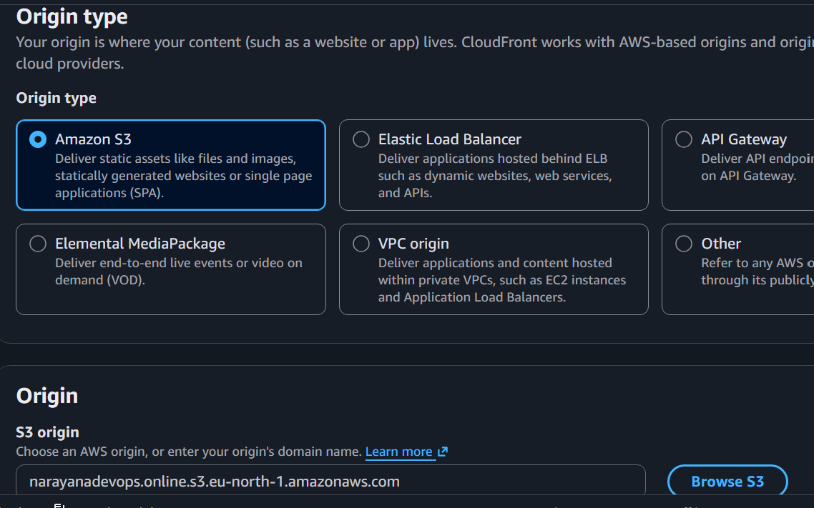
Enable security
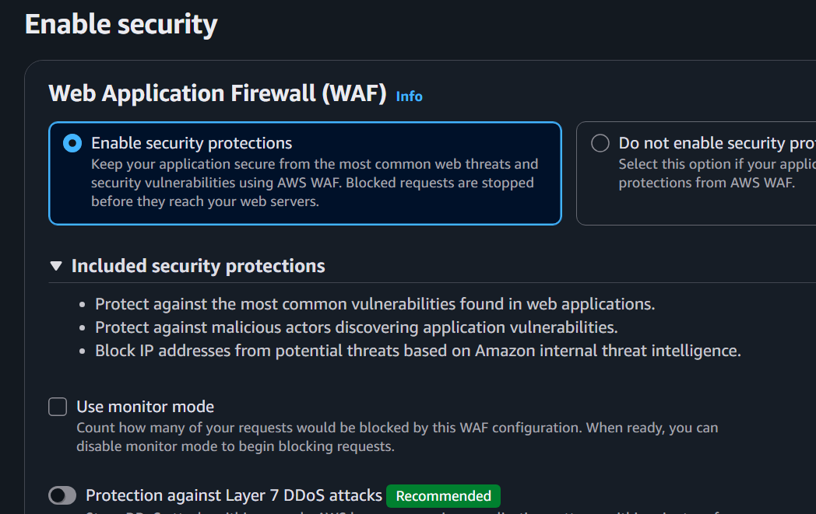
Review and create
Click Create Distribution.
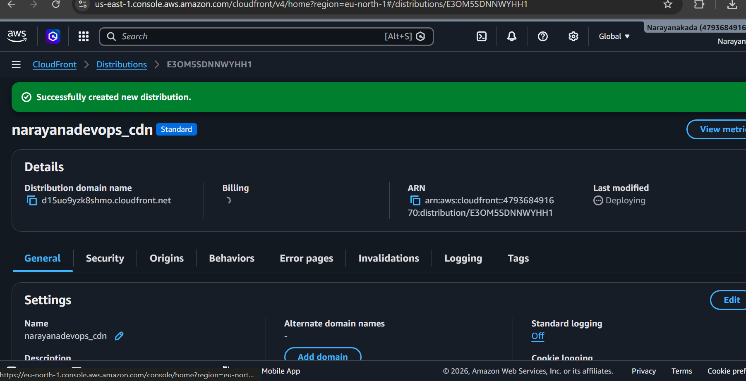
Step 3: Wait for Deployment
Go to CloudFront → Distributions.
Wait until the Status becomes:
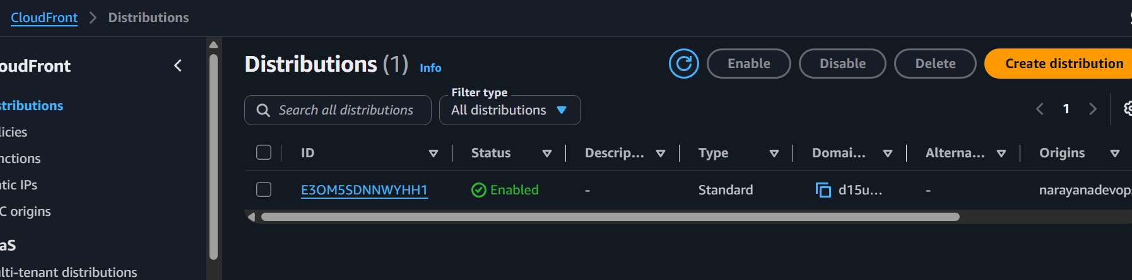
Step 4: Copy the Distribution Domain Name
Example:
d15uo9yzk8shmo.cloudfront.net
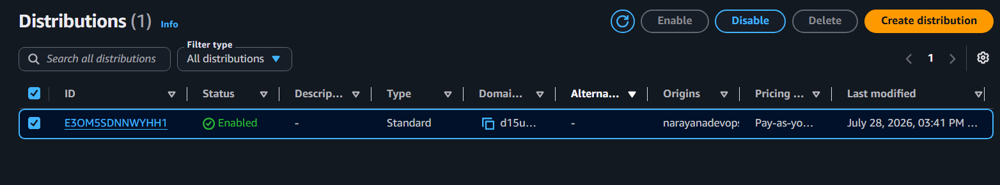
Step 5: Check Your ACM Certificate
Go to:
AWS Certificate Manager (ACM) (Region: N. Virginia / us-east-1)
Check the certificate status.
• ✅ Issued → Continue to Step 4.
5. Create a Route 53 hosted zone and map the domain with the CDN.
Step 1: Create a Hosted Zone
1. Open AWS Console.
2. Search Route 53.
3. Click Hosted zones.
4. Click Create hosted zone.
Fill in:Domain name: narayanadevops.online
type:Public hosted zone
5. Click Create hosted zone.
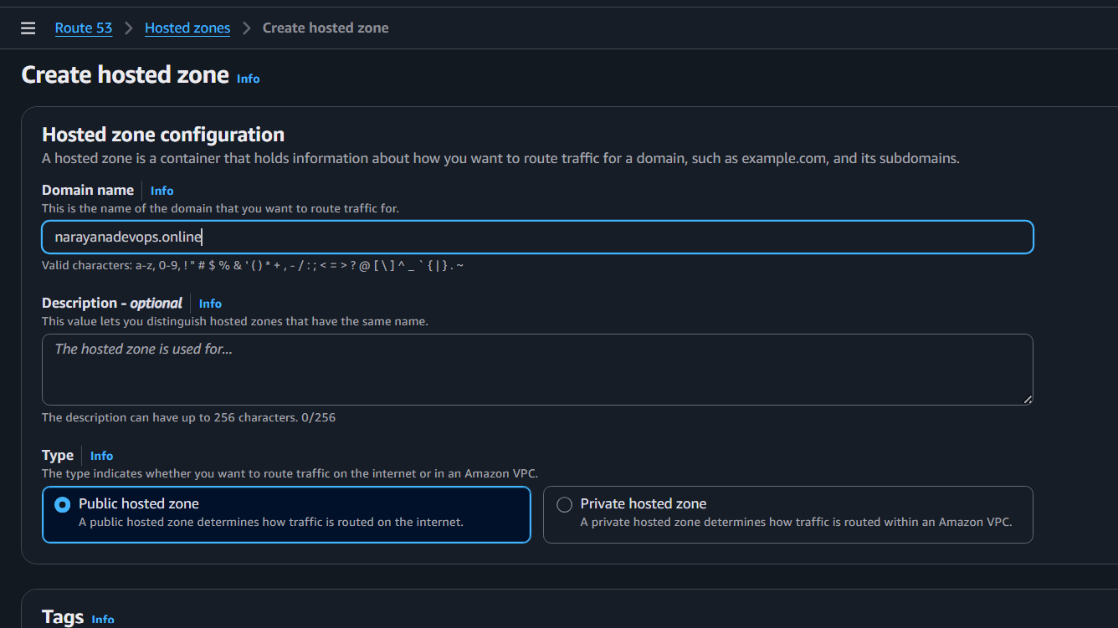
Step 2: Copy the Name Servers
After the hosted zone is created, you'll see NS and SOA records.
Open the NS record and copy the 4 Name Servers, for example:
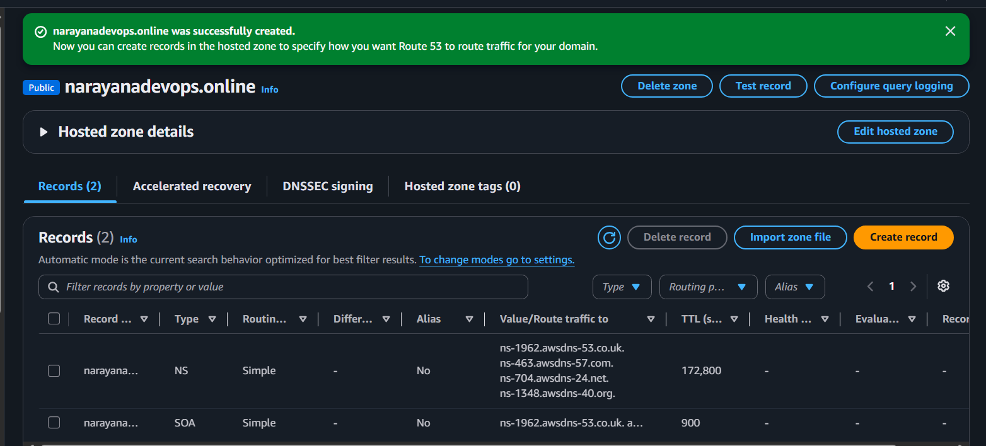
Step 3: Update GoDaddy Nameservers
1. Log in to GoDaddy.
2. Go to My Products.
3. Click DNS or Manage DNS.
4. Find Nameservers.
5. Click Change.
6. Choose:
I'll use my own nameservers

7. Replace the GoDaddy nameservers with the 4 Route 53 NS records.
8. Save.
DNS propagation may take from a few minutes up to 24–48 hours. 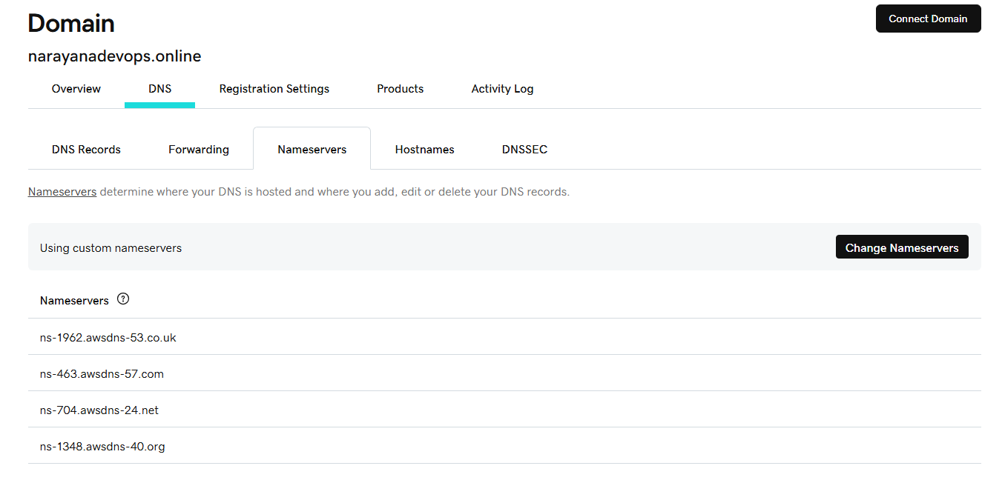
Step 4: Create an Alias Record in Route 53
After the nameservers have propagated:
1. Open Route 53.
2. Open your hosted zone.
3. Click Create record.
Configure:
Record name: Leave blank (for narayanadevops.online)
Record type: A
Alias: Yes
Route traffic to: Alias to CloudFront distribution
Select your CloudFront distribution:
Copy the domain name from the distribution and paste it
d15uo9yzk8shmo.cloudfront.net.
Click Create records.
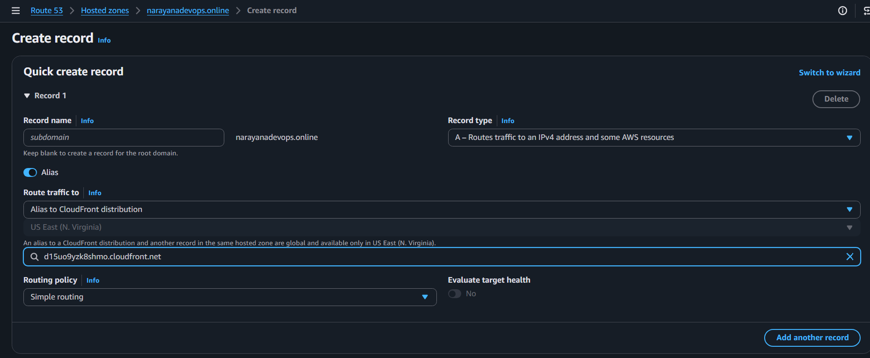
Step 5: Create a www Record
Click Create record again.
Record name: www
Type: A
Alias: Yes
Alias target: Same CloudFront distribution.
Click Create records.
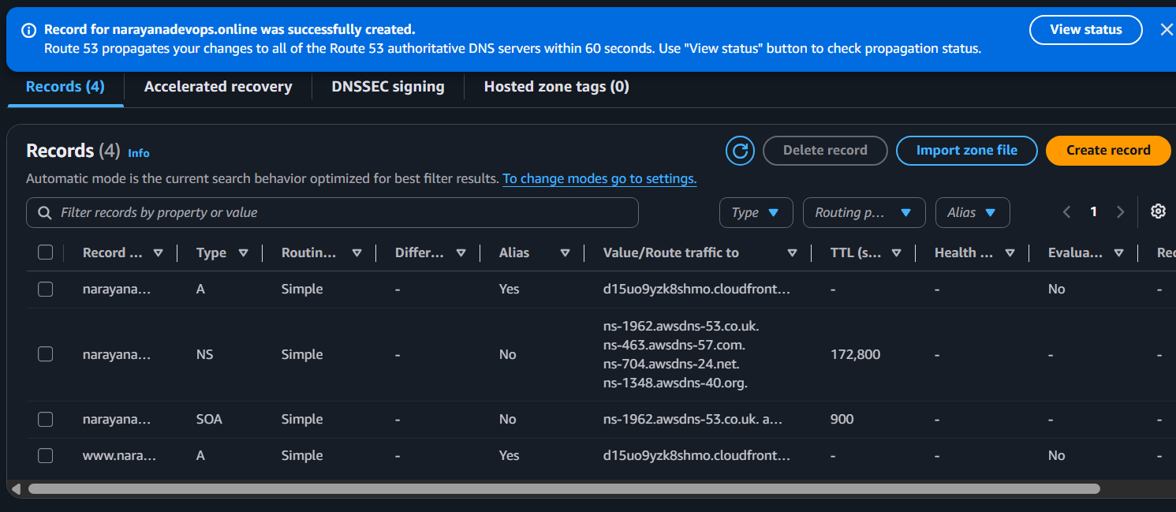
Step 6: Test
After DNS propagation, open:
https://narayanadevops.online
should load your CloudFront-served S3 website over HTTPS.

6. Update the index.html in the S3 bucket and ensure the updated file is accessible
using the domain name.
Objective
Update the website content stored in the S3 bucket and verify that the updated
content is accessible through the custom domain.
Step 1: Edit index.html
Open the index.html file on your computer and change the content.
Save the file.
<!DOCTYPE html>
<html>
<head>
<title>Narayana DevOps Portfolio</title>
</head>
<body style="text-align:center; font-family:Arial;">
<h1>Welcome to Narayana DevOps Portfolio</h1>

<h2>Hosted on Amazon S3</h2>

<h3>Delivered through Amazon CloudFront</h3>

<h3>Domain: narayanadevops.online</h3>

<h3>SSL Enabled (HTTPS)</h3>

<h3>Created by Kada Lakshmi Narayana</h3>

<p>This website demonstrates AWS S3, CloudFront, ACM, Route 53 and GoDaddy integration.</p>
</body>
</html>
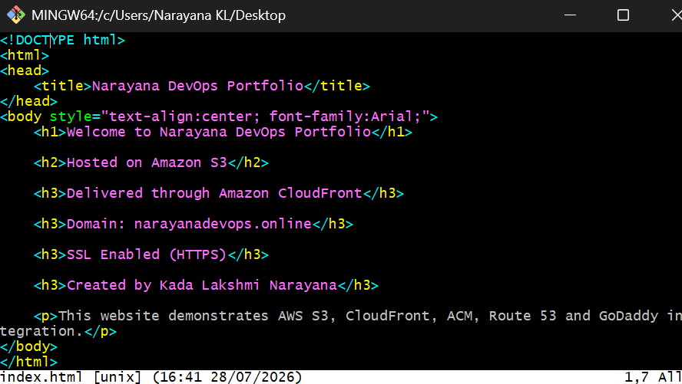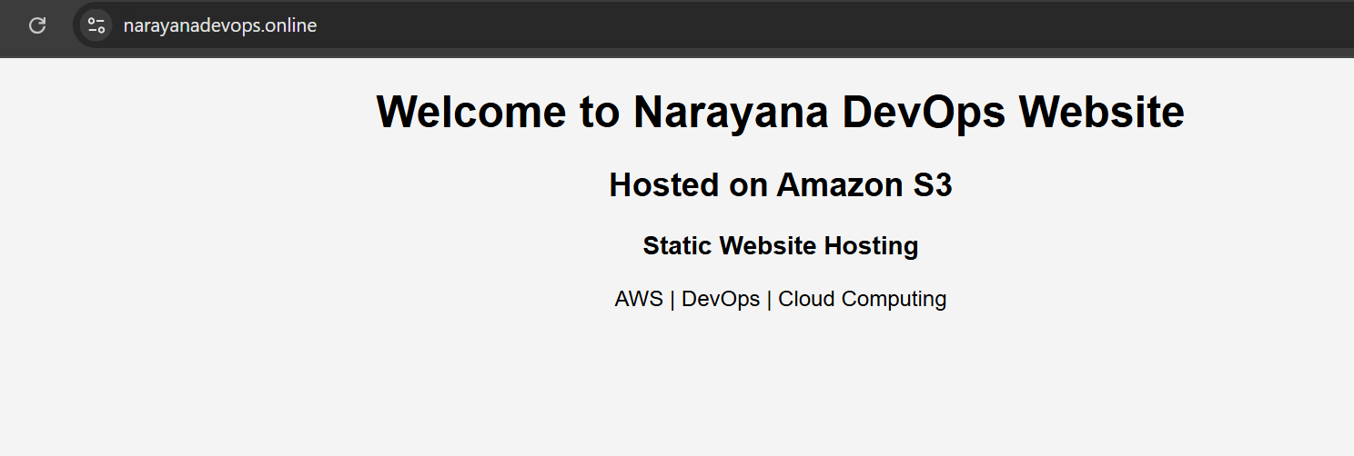
Again change the text
<!DOCTYPE html>
<html lang="en">
<head>
<meta charset="UTF-8">
<meta name="viewport" content="width=device-width, initial-scale=1.0">
<title>Narayana DevOps Portfolio</title>

<style>
body{
margin:0;
padding:0;
background:#f4f4f4;
font-family:Arial, Helvetica, sans-serif;
}

.container{
width:80%;
margin:50px auto;
background:white;
padding:40px;
border-radius:10px;
box-shadow:0px 0px 15px rgba(0,0,0,0.2);
text-align:center;
}

h1{
color:#0073e6;
}

h2{
color:#444;
}

h3{
color:#666;
}

hr{
margin:30px 0;
}

ul{
list-style:none;
padding:0;
}

ul li{
padding:8px;
font-size:18px;
}

.footer{
margin-top:30px;
color:green;
font-weight:bold;
}
</style>

</head>

<body>

<div class="container">

<h1>Welcome to Narayana DevOps Portfolio</h1>

<h2>Hosted on Amazon S3</h2>

<h2>Delivered through Amazon CloudFront</h2>

<h2>Domain: narayanadevops.online</h2>

<h2>HTTPS Enabled</h2>

<h2>Created by Kada Lakshmi Narayana</h2>

<hr>

<h2>AWS Services Used</h2>

<ul>
<li>Amazon S3</li>
<li>Amazon CloudFront</li>
<li>AWS Certificate Manager (ACM)</li>
<li>Amazon Route 53</li>
<li>GoDaddy Domain</li>
</ul>

<hr>

<h2>Project Features</h2>

<ul>
<li>Static Website Hosting</li>
<li>HTTPS Enabled using SSL Certificate</li>
<li>Global Content Delivery using CloudFront CDN</li>
<li>Custom Domain Mapping</li>
<li>Fast and Secure Website Delivery</li>
</ul>

<hr>

<h2>Technologies</h2>

<h3>AWS | DevOps | Cloud Computing</h3>

<div class="footer">
Deployment Successful
</div>

</div>

</body>
</html>
Step 2: Upload the updated file
1. Open AWS Console
2. Go to S3
3. Open your website bucket.
4. Select index.html
5. Click Upload
6. Choose the updated index.html
7. Click Upload
The old file will be replaced.
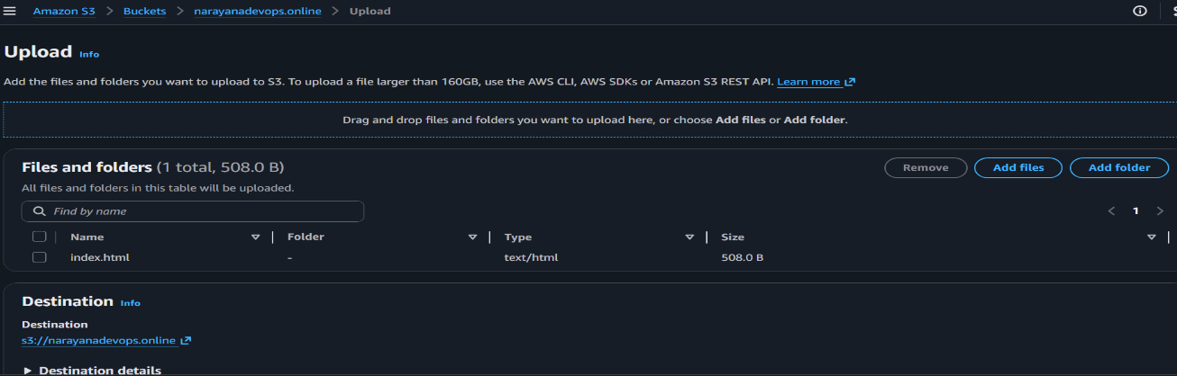
Step 3: If using CloudFront, invalidate the cache
Without invalidation, CloudFront may continue serving the old page.
1. Open CloudFront
2. Select your distribution.
3. Go to Invalidations
4. Click Create Invalidation
5. Enter:
/*
6. Click Create Invalidation
